http://www.targetmarketingmag.com/post/7-cool-mail-involvement-devices/:
 By Paul Bobnak
7 Cool Direct Mail Involvement Devices
You want your direct mail to avoid the recycling basket, but how? One good way is to consider involvement devices. These techniques require a prospect to take an action — like peel off a sticker or remove a coupon or a personalized card — to proceed.
Because of what I’ve seen over the years in reviewing mail for Who’s Mailing What!, there are a lot of good ones out there. A lot. But, I have limited space, so here are seven good ones.

Backstage Pass
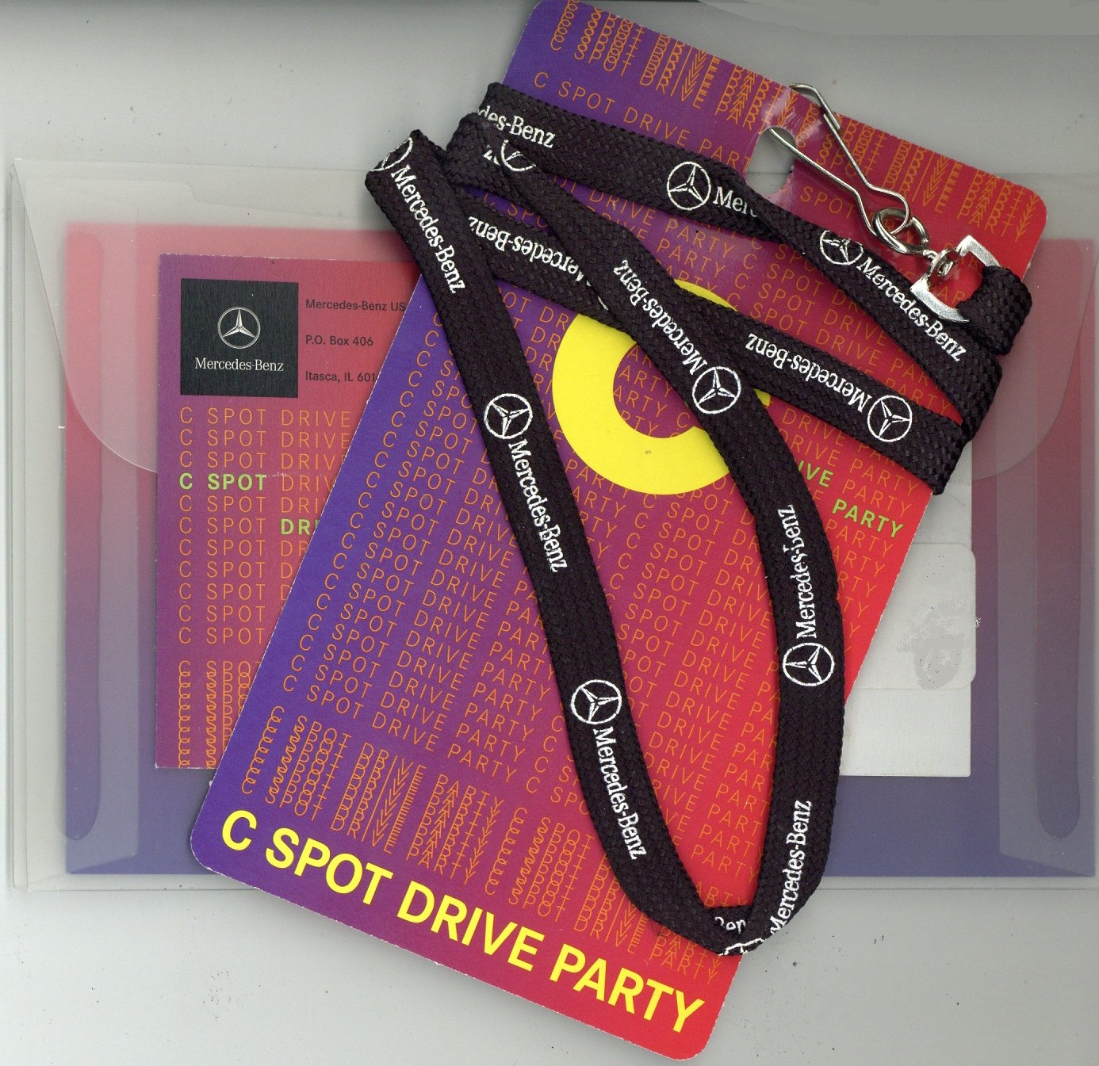
Call it what you want – the all-access pass or VIP pass – everyone wants to feel special. Exclusive. Mercedes-Benz mailed this pass to drive leads for one of its Drive Party events. Whether it’s used for a carmaker’s test drive, or a special fundraising gala, the pass is a fun way to boost an ego.

Money
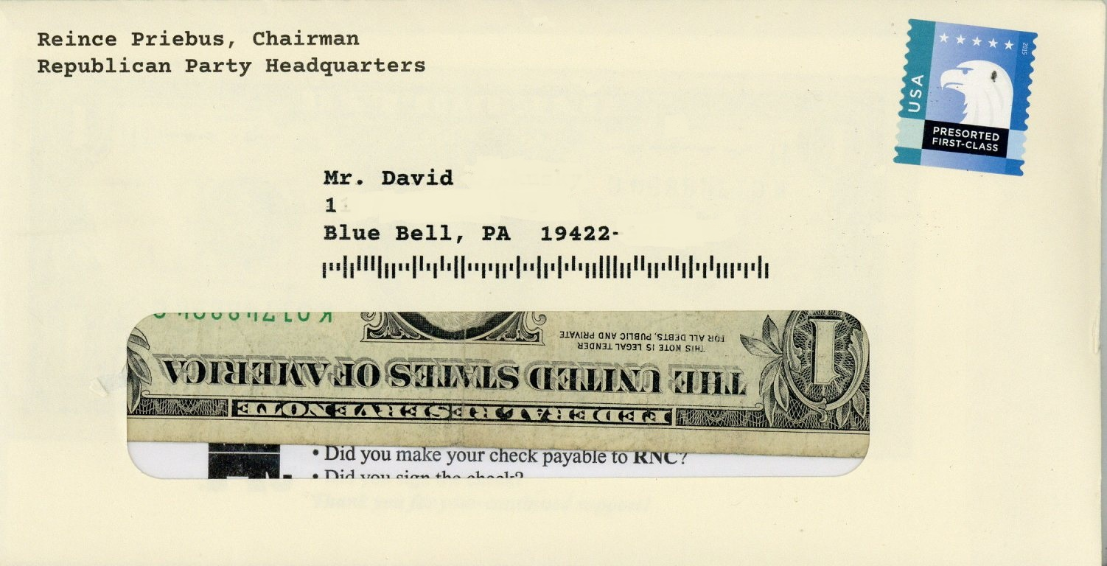
There’s nothing like cold, hard cash to motivate someone to donate to a cause. Usually, a nonprofit will include a coin in the package. Here, the Republican National Committee recently mailed a $1 bill to “get your attention quickly,” as the letter put it. It is odd that it used the envelope’s address window to show the money front and center. The ask, though, is the same: return the money, with some of your own.

Samples
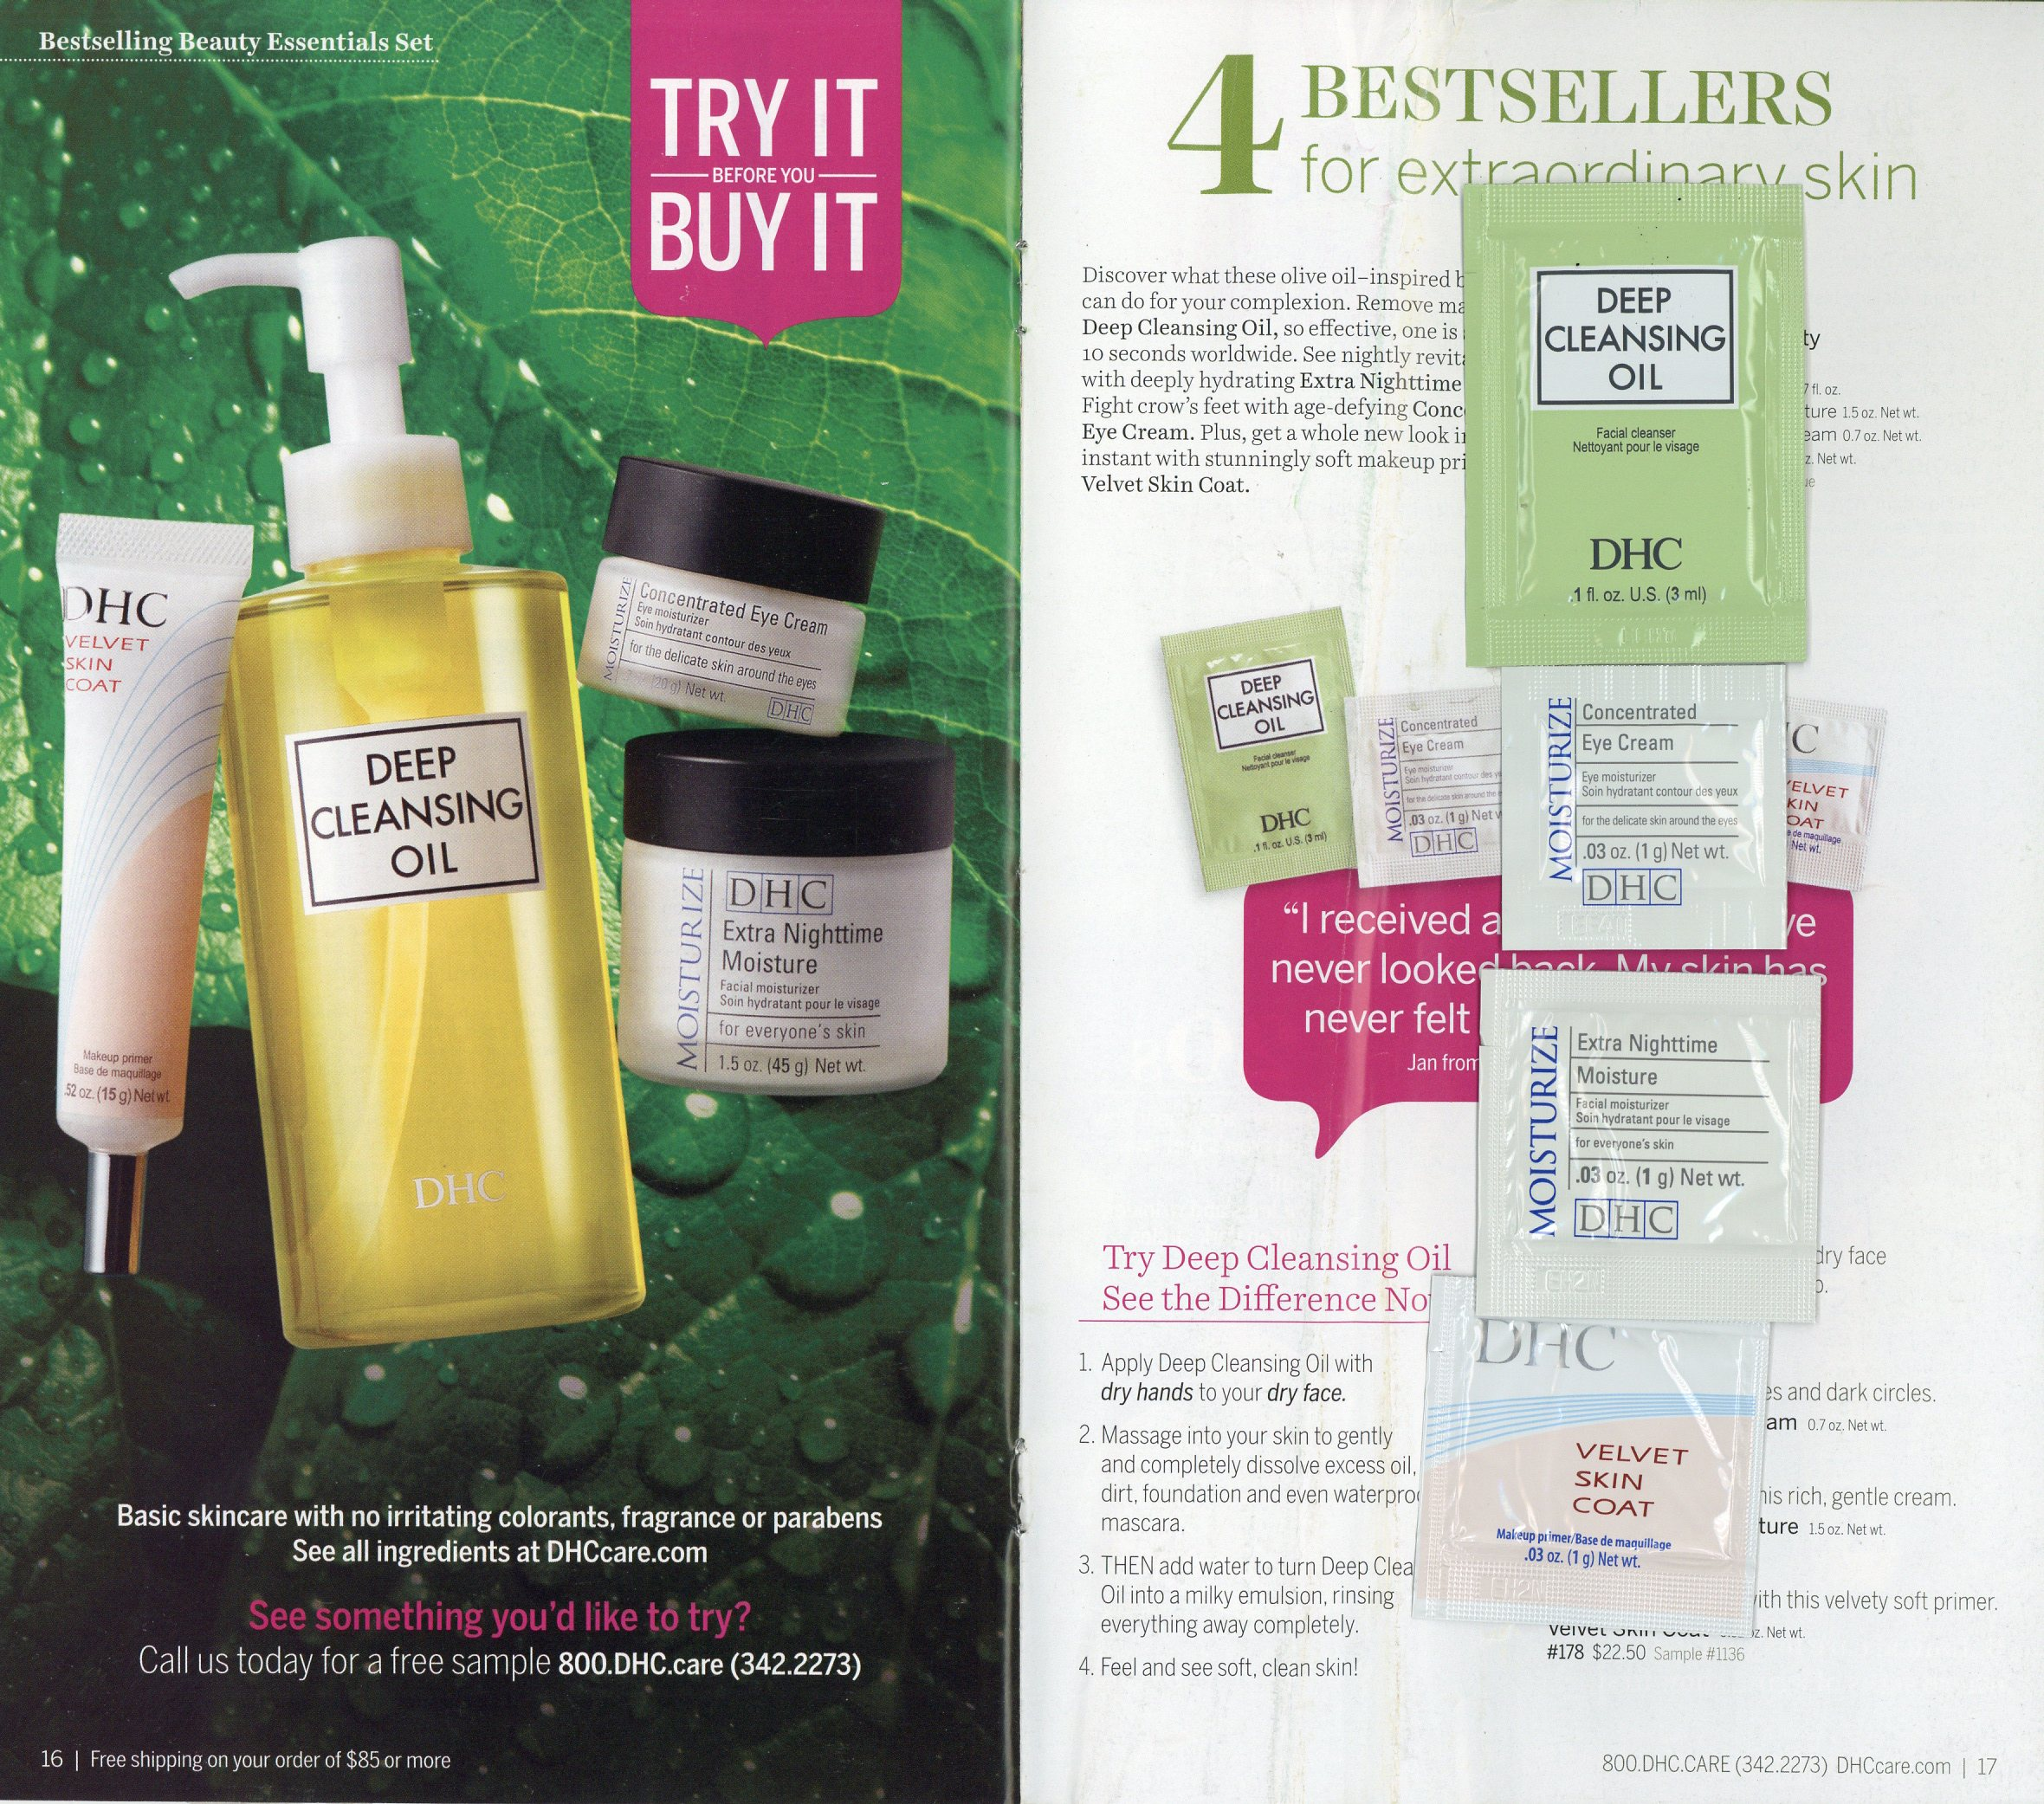
DHC USA, a makeup and skincare brand, includes samples in its catalogs. The company literally puts its products in the hands of its customers, and proves that they work. This spread from its catalog shows four of its bestsellers, with descriptions of each and a testimonial as well.

Ring Sizers
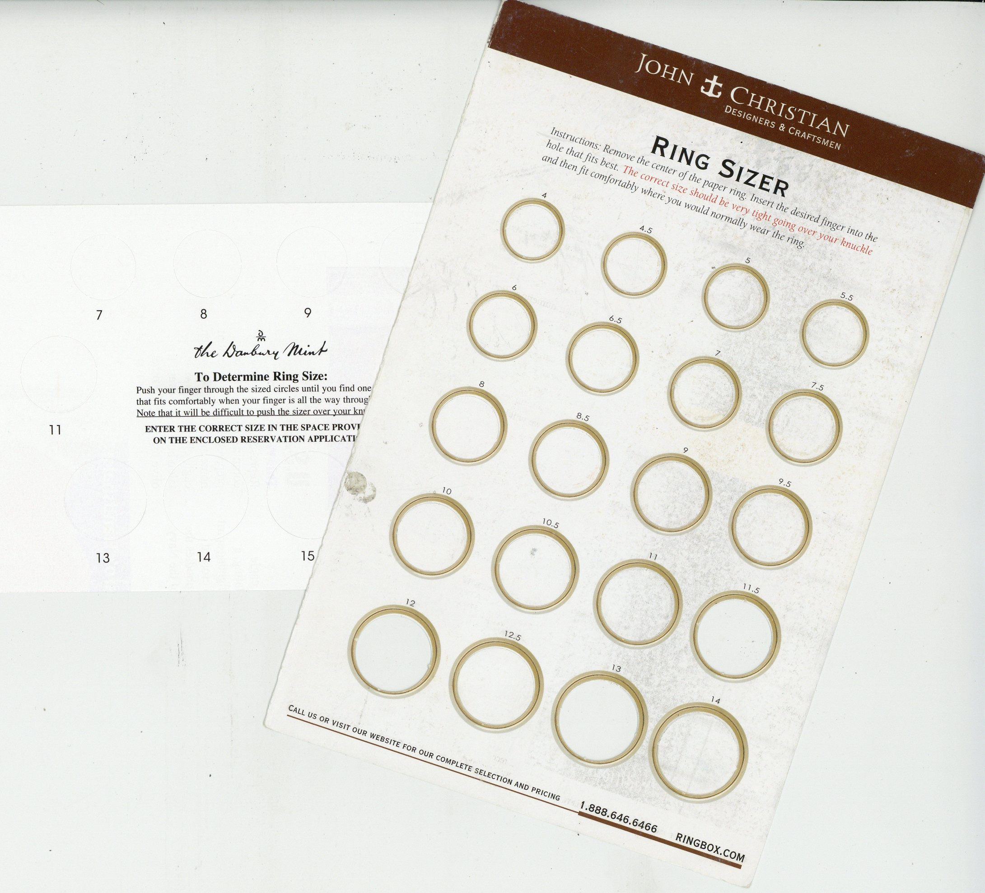
OK, this one is pretty specialized. Companies selling jewelry, like John Christian and The Danbury Mint, help customers figure out what size ring they wear, or should wear. Instead of visiting a brick-and-mortar store, they only need to go online or make a phone call.

Quizzes
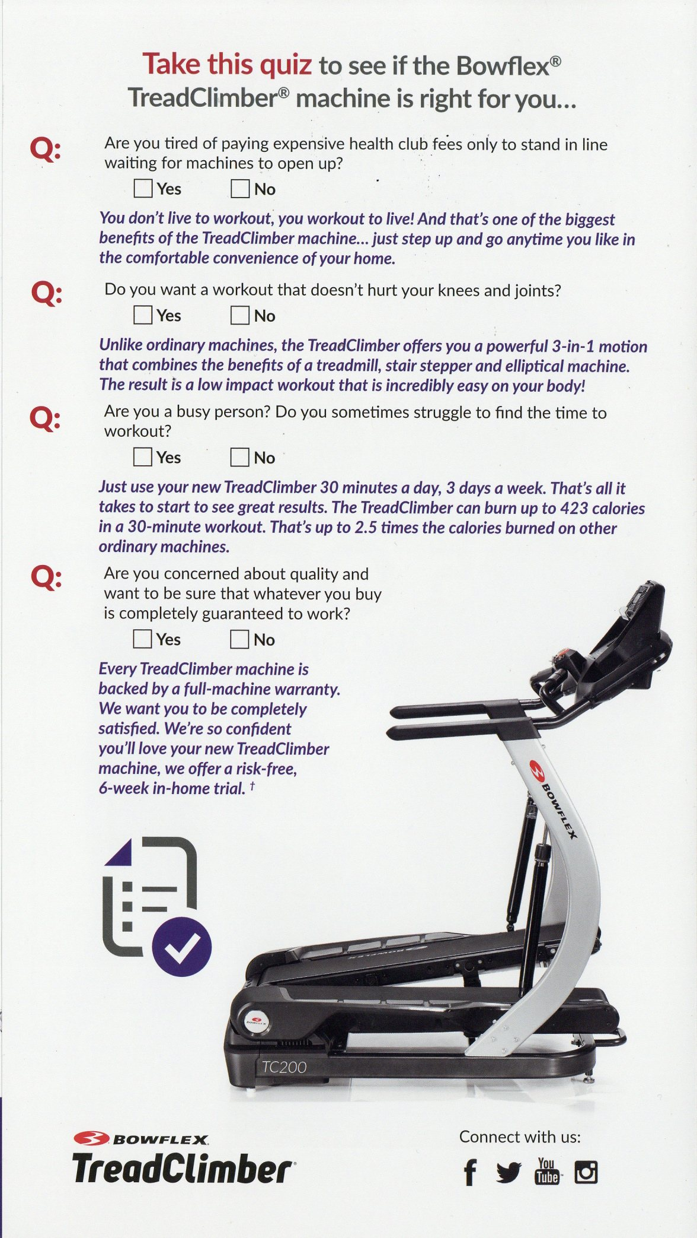
Providing questions and answers gets a customer to think in a different way about the product or service the mail piece offers. Sure, the questions may be leading … but that’s exactly what you want. In this example, Bowflex asks four questions of the prospect. “Do you want a workout that doesn’t hurt your knees and joints?” Who’s going to answer “no”? Each “yes” answer gives the company a chance to help the prospect realize that they qualify or even need the product.

Checklist
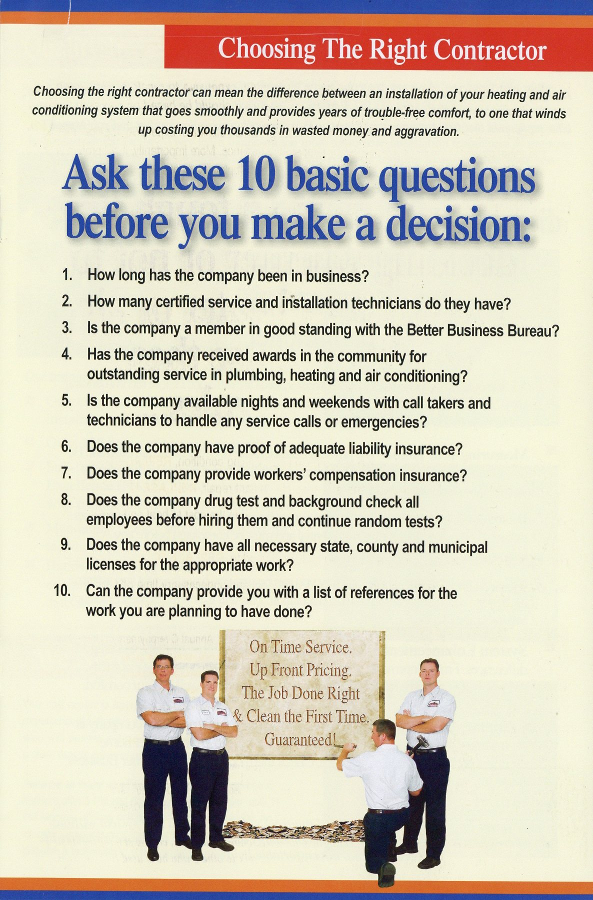
I’ve talked about the folks at Horizon Services before. They’re masters of content marketing, and this list is taken from one of their brochures. For any homeowner facing some very expensive decisions, this is something they can have in hand as they consider their next move.

Booklets and Postcards

Dissolve, a video stock footage supplier, puts a variety of goodies in the mail to drum up inquiries from business customers. It mailed a pack of postcards with images from some of its most popular collections. The goal is to “inspire your life and improve your video projects.” And, their pocket-sized red books are blank inside. “[F]ill these pages with every script idea, ad concept, storyboard sketch, and rough design that comes to mind,” it urges.
The common denominator to all of these is touch. Each item gets the prospect to physically spend more time with your promotion’s message. Every minute that they think about your message, even indirectly, increases the likelihood that they will order.
Do you have some favorite, cool, or unusual involvement devices? I'd love to know. Let's talk about them in the comments below!

An Organizational Structure for Modern Marketing Success.
You will be surprised how much marketing departments have changed in just a few short years. Traditional B-to-B marketing organization models are no longer a good fit. Do you or your department have the right skills to handle today’s marketing challenges?
Learn more here »

